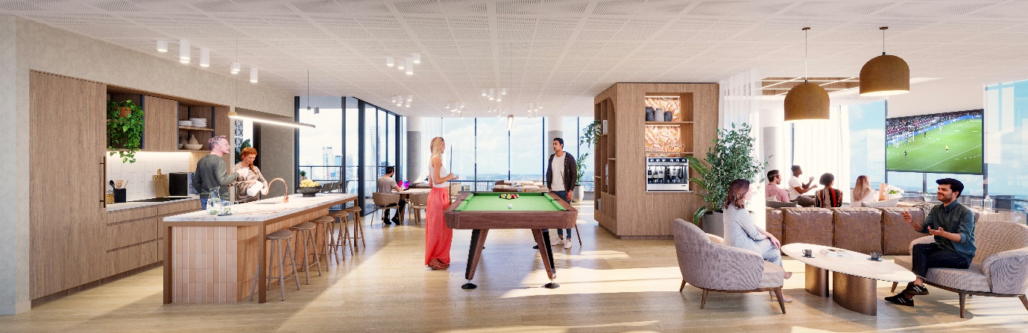

EXHIBITION QUARTER, BOWEN HILLS

WHAT: PROJECT UPDATE 5 - COMMUNITY CONSTRUCTION INFORMATION

WHEN: ISSUED WEEK COMMENCEING – 20th May 2023

WHERE: BRISBANE SHOWGROUNDS PRECINCT

To our valued community,

Construction of Exhibition Quarter is progressing well. Civil works continue, and as expected these works will be completed by the end April 2023. The next phase of construction will require the use of two cranes.
Works Underway
The crane will be arriving on site on Saturday 29th April. The arrival of the crane will impact the traffic in the area, and Alexandria St will be closed from 6.30am to 6.30pm.
During this time, traffic will be redirected via Machinery St and King St.
Upcoming Works
The introduction of these cranes will not change or increase the construction impacts onsite. The cranes are onsite until early 2025.
We will continue to do everything possible to minimise any inconvenience and we thank you for your patience while we deliver this exciting new project to Brisbane Showgrounds.
General Information

Want to know more
If you have any further questions about the development or the broader precinct, please do not hesitate to contact Shannon Volp, Stakeholder and Community Engagement Manager, Lendlease Development or visit our website www.exhibitionquarterowenhills.com.au
For any site specific or operational questions, please contact to Mario Crismani, Construction Manager, Hutchinson Builders.
Yours sincerely,

Shannon Volp Mario Crismani
Stakeholder and Community Engagement Manager Construction Manager
Lendlease Development Hutchinson Builders
0438 468 536 0431 642 335
Shannon.volp@lendlease.com mario.crismani@hutchies.com.au

