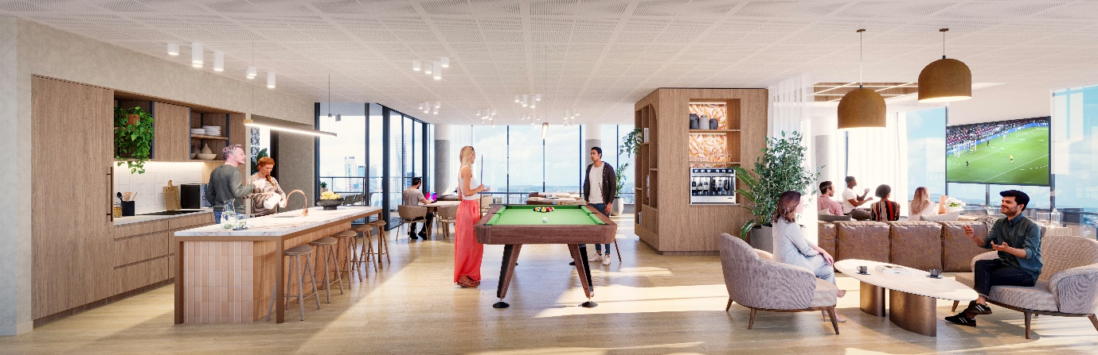

EXHIBITION QUARTER, BOWEN HILLS

WHAT: PROJECT UPDATE 7 - COMMUNITY CONSTRUCTION INFORMATION

WHEN: ISSUED WEEK COMMENCING 3rd July 2023

WHERE: BRISBANE SHOWGROUNDS PRECINCT

To our valued community,

Works underway
Construction of Exhibition Quarter is progressing well. We are continuing to complete large scale concrete works, so please be aware there are a number of concrete trucks coming to and from site daily.
The next phase of work will require the use of two cranes, as previously notified.

Upcoming works
Due to unforeseen circumstances, the installation of the second crane has been slightly delayed. This will now be arriving on site on Saturday 15th July. No other details have changed.
The arrival of the crane will impact the traffic in the area, and Alexandria St will be closed from 6.30am to 6.30pm. During this time, traffic will be redirected via Machinery St and King St.
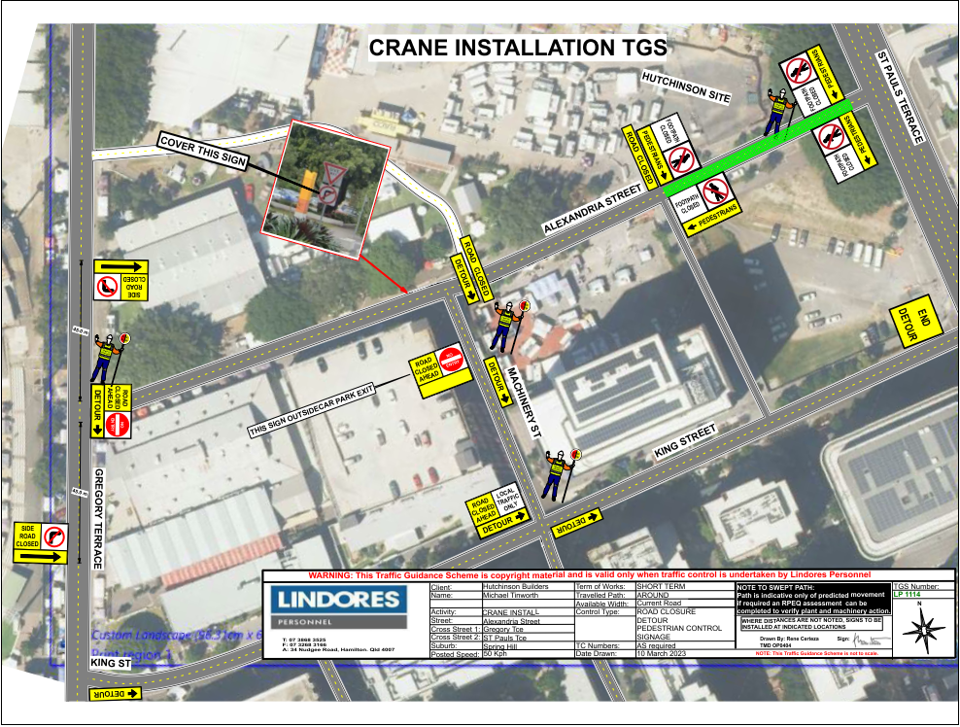
The introduction of this second crane will not change or increase the construction impacts onsite. The cranes are expected to be onsite until early 2025.
General information
We will continue to minimise any inconvenience where possible and we thank you for your patience while we deliver this exciting new project to Brisbane Showgrounds.
For more information
If you have any further questions about the development or the broader precinct, please do not hesitate to contact Shannon Volp, Stakeholder and Community Engagement Manager, Lendlease Development or visit our website www.exhibitionquarterowenhills.com.au
For any site specific or operational questions, please contact to Mario Crismani, Construction Manager, Hutchinson Builders.

Yours sincerely,

Shannon Volp Mario Crismani
Stakeholder and Community Engagement Manager Construction Manager
Lendlease Development Hutchinson Builders
0438 468 536 0431 642 335
Shannon.volp@lendlease.com mario.crismani@hutchies.com.au

