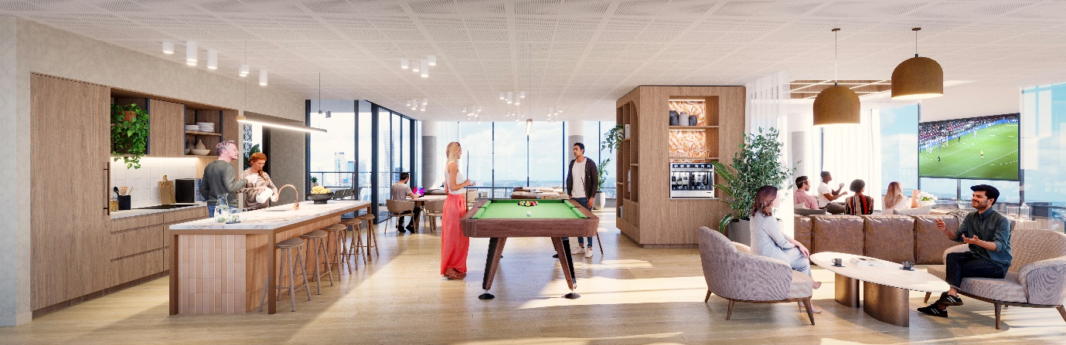

EXHIBITION QUARTER, BOWEN HILLS

WHAT: PROJECT UPDATE 9 - COMMUNITY CONSTRUCTION INFORMATION

WHEN: ISSUED WEEK COMMENCING 9th October 2023

WHERE: BRISBANE SHOWGROUNDS PRECINCT

To our valued community,

Works underway
Construction of Exhibition Quarter is progressing well. We are continuing to complete large scale concrete works, so please be aware there are a number of concrete trucks coming to and from site daily.
Upcoming works
The next phase will include works that will impact Exhibition Street. We intend to commence works on Exhibition Street during the week of the 16th of October 2023 and works are expected to take two weeks.
These works will include:
- Removal of powerlines and streetlights on the RNA side of Exhibition Street.
- Trenching and installation of new electrical mains across Exhibition Street and into the site.
Works activities and work zones will change from day to day, but traffic control will be in place at all times when work is occurring, and all normal pedestrian and vehicle traffic will be maintained.
All works will be completed during normal business hours and no out of hours works are planned as part of this activity. Exhibition Street will be returned to normal operation and traffic control will not be present when no works are occurring.
General information
We will continue to minimise any inconvenience where possible and we thank you for your patience while we deliver this exciting new project to Brisbane Showgrounds.
For more information
Included with this letter is the King St Community Newsletter. This includes information on the project and other activities, events, and information for the Brisbane Showgrounds precinct.
If you have any further questions about the development or the broader precinct, please do not hesitate to contact Shannon Volp, Stakeholder and Community Engagement Manager, Lendlease Development or visit our website www.exhibitionquarterowenhills.com.au
For any site specific or operational questions, please contact to Mario Crismani, Construction Manager, Hutchinson Builders.

Yours sincerely,

Shannon Volp Mario Crismani
Stakeholder and Community Engagement Manager Construction Manager
Lendlease Development Hutchinson Builders
0438 468 536 0431 642 335
Shannon.volp@lendlease.com mario.crismani@hutchies.com.au

